Antiochian
February 2021
Website: www.antiochianumc.com
Facebook: antiochumc
Dear Antioch Church,
Happy New Year!
²² You were taught, with regard to your former way of life, to put off your old self, which is being corrupted by its deceitful desires; ²³ to be made new in the attitude of your minds; ²⁴ and to put on the new self, created to be like God in true righteousness and holiness. Ephesians 4:22-24
I pray a blessing over the New Year in 2021. May the New Year bring peace, normalcy and resolution back to our lives. More importantly a deeper faith in God and His Son Jesus Christ. I wish that everyone knows Christ as their Savior. I have a list of scripture text to share with you.
Isaiah 43:18-19 ¹⁸ “Forget the former things; do not dwell on the past. ¹⁹ See, I am doing a new thing! Now it springs up; do you not perceive it? I am making a way in the wilderness and streams in the wasteland.
2 Corinthians 5:17 ¹⁷ Therefore, if anyone is in Christ, the new creation has come: The old has gone, the new is here!
2 Chronicles 7:14 ¹⁴ if my people, who are called by my name, will humble themselves and pray and seek my face and turn from their wicked ways, then I will hear from heaven, and I will forgive their sin and will heal their land.
Romans 8:31 ³¹ What, then, shall we say in response to these things? If God is for us, who can be against us?
Isaiah 40:29-31 ²⁹ He gives strength to the weary and increases the power of the weak. ³⁰ Even youths grow tired and weary, and young men stumble and fall; ³¹ but those who hope in the Lord will renew their strength. They will soar on wings like eagles; they will run and not grow weary, they will walk and not be faint.
Proverbs 3:5-6 ⁵ Trust in the Lord with all your heart and lean not on your own understanding;
⁶ in all your ways submit to him, and he will make your paths straight.
Matthew 7:7-8 ⁷ “Ask and it will be given to you; seek and you will find; knock and the door will be opened to you. ⁸ For everyone who asks receives; the one who seeks finds; and to the one who knocks, the door will be opened.

God bless you,

Pastor Keith

Altar Flowers
Feb 7 -
Feb 14 -
Feb 21 -
Feb 28 -
Open Dates on Altar Flower Calendar!
We now have a flower calendar, which is located just inside the front door of the church (the door with the ramp) on the bulletin board on the right hand wall coming in.
We still have many openings for this year. Please consider signing up for one of the open Sundays. The cost is still $25.00 and the altar flower arrangements were beautiful this last year. You may designate them in honor of an anniversary or birthday, or in memory of a loved one who has passed. Once you sign up, they are easy to pay for. Just put your check or money in one of the pew envelopes and mark it for FLOWERS and the date. You do not need to pay for them until it is your Sunday and it is a wonderful way to remember someone, and don’t forget to take them home after the service, or give them to someone who just needs something to brighten their day. Thank you.

New Testament Bible Trivia Questions
The following are trivia questions to test your general knowledge of the New Testament. Some are very easy while others you may need to look up. Have fun: Answers can be found on the last page before color sheets or calendar.
- In what city was Jesus born?
- How many books are in the New Testament?
- What type of insect did John the Baptist eat in the desert?
- Who were the first apostles called to follow Jesus?
- How many people did Jesus feed with just five loaves of bread and two fish?
- After Jesus was arrested, which apostle disowned him three times?
- Who recognized Jesus as the Messiah, when he was presented to the Temple as a baby?
- Who ask Pilate for Jesus’s body after the crucifixion?
- Paul was shipwrecked on what island?
- What is the shortest book in the New Testament?
- Who is the author of the Book of Revelation?
- Matthew was a ____________ ? (job)
- To what city was Saul traveling when he encountered a great and blinding light?
- Who was the first person to come upon the injured man in the parable of the Good Samaritan?
- Finish this verse. “In every battle you will need faith as your ______ to stop the fiery arrows aimed at you by Satan.”
- Whose example does Paul say Christians should follow in Chapter 5 of Ephesians?
- After Jesus fed 5000 plus people with two fish and five loaves of bread, how many baskets of food were left over?
- What does Paul say may_____”abound more and more in knowledge and in all judgment?”
- What tribe is Paul from?
- According to the Beatitudes who will be filled?
- What did Simon Peter do for a living before he became an apostle?
- In the Gospel of Mark, how does the Virgin Mary learn of her pregnancy?
- Who is Stephen in Acts of the Apostles?
- By what name is Paul of Tarsus known before he begins his missionary activity?
- According to Paul’s formulation in 1 Corinthians which is the greatest of the imperishable qualities?
- Who is the high priest of Jerusalem who put Jesus on trial?
- In the Gospel according to John, which of the apostles doubts Jesus’s resurrection until he sees Jesus with his own eyes?
- According to the Gospel of Matthew, where does Jesus’s first public sermon take place?
- How does Judas signal Jesus’s identity to the Roman officials?
- Who murders John the Baptist?
- When Christians observe Palm Sunday, what biblical narrative are they celebrating?
- According to the Gospels, what is the unique literary genre Jesus employs to preach his message?
- Which Gospel is most concerned with the mystery and identity of the person of Jesus?
- Who baptizes Jesus?
- Who takes Jesus’s body off the cross?
- Who is the first apostle to deny Jesus?
- Which Gospel is written by a doctor?
- How many days did Jesus wander in the desert while being tempted by the Devil?
- What did Jesus say the bread and the wine represent at the last supper?
- What chapter of the Bible is referred to as the Love chapter?

Blanket Sunday
Blanket Sunday is February 14. Please consider donating $5.00 or more for a blanket or mosquito netting for needy people around the world in desperate situations. HAVE A HEART—DONATE TO HELP OTHERS. We will be collecting money the entire month of February. Please mark your check or envelope for Blanket Sunday.
Thank you,
Linda Hall

Thanks to everyone who filled a Samaritan’s Purse Christmas
Child box in November. We filled 26 boxes which was less than last year, but a decent amount during a pandemic. The Women’s Circle gave a $100.00 donation to help with the shipping.

We are hoping the Native American school supplies and other items will be able to be delivered in the spring, if the virus lets up. The Indians can make use of all we collected for them. Thanks for all your donations.
Linda Hall

Ash Wednesday

Ash Wednesday is on February 17th. Due to the
Covid 19 virus, we are not able to tell you if the ashes can be presented as they have been in the past. Just stay tuned. Check out our website, watch the church service from home on Sundays, or come to church if you feel comfortable doing so. Social distancing is observed and mask are worn
Thank you for understanding.

Easter is not until April 1st. Stay tuned for updates on services and future plans as the time comes closer and we see how things are going with the virus.

Spring will soon be here, so it is never too early to start planning for our Annual Spring Dinner. It appears that we will again be serving our dinner by having a drive thru here at Antioch UMC. Please mark your calendars for Saturday, March 20, 2021, from 4:00 to 6:30 PM, and tell your family and friends about this event.

Our fall drive thru was a great success, but we learn from our mistakes and are changing a few things for better quality control, and to see that everyone gets everything they ordered. Watch for more details in the March Antiochian. Thank you.

Women’s Circle Meeting

The United Methodist Women’s Circle will meet Monday, February 1, 2021, at 10:30 am in the church social room. Mickey Johnston will be presenting the program. All ladies are invited to attend, please plan to come and join us! Social distancing and wearing of masks are also being observed at this time.

Eye Glasses Collection
When you start cleaning this spring or any time during the year, please bring your old eye glasses, frames, and cases to church and place them in the box on the shelf in the Narthex marked “Glasses”.
These can be recycled to help others less fortunate to see. Thank you!

Whatever comes from
The heart
Quietly touches every
Other heart!

Trivia Answers

- Bethlehem
- 27
- Locusts
- Peter and Andrew
- Approximately 5000 men
- Peter
- Simeon
- Joseph of Arimathea
- Malta
- 2 John
- John
- Tax collector
- Damascus
- A Priest
- Shield
- Christ’s
- 12
- Love
- Benjamin
- Those who hunger and thirst for righteousness.
- He was a fisherman
- From the angel Gabriel
- The first Christian martyr
- Saul
- Love
- Caiaphas
- Thomas
- On the mount
- He kissed him
- Herod Antipas
- Jesus’s entry into Jerusalem before his death.
- The parable
- John
- John the Baptize
- Joseph of Arimathea
- Peter
- Luke
- 40 days and nights
- Bread was his body the wine his blood
- 1 Corinthians Chapter 13

Just for Kids
Valentines they can make!
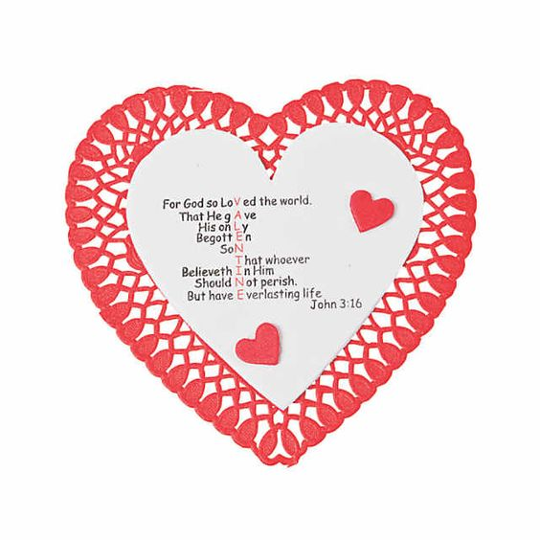

Antiochian
February 2021
Antioch United Methodist Church
10301 Wolf Creek Pike
Trotwood, OH 45426-4259

(937-837-6348)
Pastor Keith Smallenbarger: Cell (937-510-5549)
Newsletter E-Mail: antiochian@frontier.com
Office E-Mail: antiochoffice@frontier.com
Website: www.Antiochumc.org
Facebook: antiochumc

DATED MATERIAL ENCLOSED
RETURN SERVICE REQUESTED

Come Experience the Transforming

Love of God with Us…..
Sunday School 9:45 a.m.

Worship Celebration 11:00 a.m.

